Steps for execution:

1.Run the server through IDE

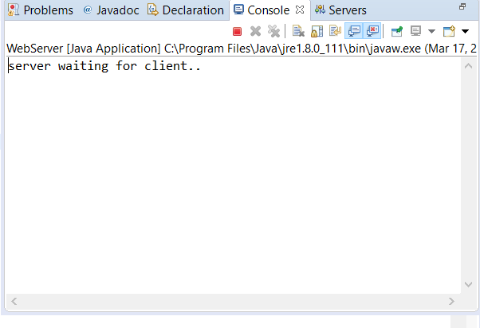

2. Run the client through IDE or browser

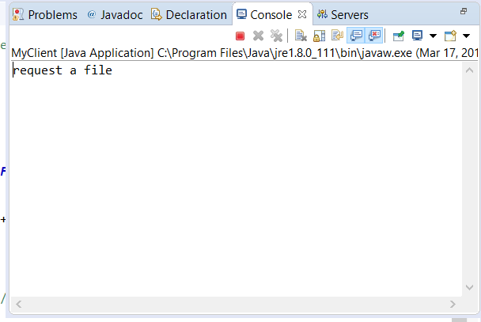

OR C:\Users\sundeep4sandy\AppData\Local\Microsoft\Windows\INetCache\Content.Word\chrome-imput.png

3. Type the name:

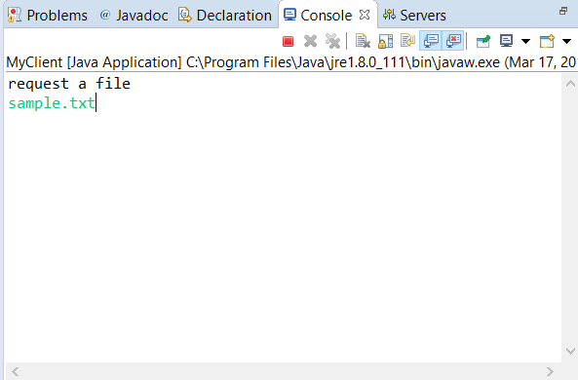

4. The file is sent:

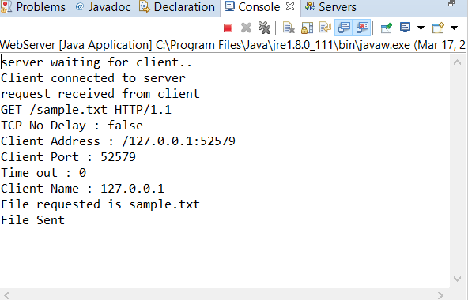

5. Output:

